**Vivekanand Education Society's Institute of Technology**

**Department of Computer Engineering**



**Mini Project on**

**LIBRARY MANAGEMENT SYSTEM**

**Subject: OSTL Semester: IV Class: D7C**

**Presented By:**

**Sahil Talreja-64**

**Kanchan Shownkeen-62**

**Muskan Shaikh-57**

**INTRODUCTION:**

A Library Management System is a software built to handle the primary housekeeping functions of a library. Libraries rely on library management systems to manage asset collections as well as relationships with their members. Library management systems help libraries keep track of the books and their checkouts, as well as members’ subscriptions and profiles.Library management systems also involve maintaining the database for entering new books and recording books that have been borrowed with their respective due dates.

**History/Existing system:**

### Pre-computerization

Prior to computerization, library tasks were performed manually and independently from one another. Selectors ordered materials with ordering slips, cataloguers manually catalogued sources and indexed them with the [card catalog](https://en.wikipedia.org/wiki/Card_catalog) system (in which all bibliographic data was kept on a single index card), fines were collected by local bailiffs, and users signed books out manually, indicating their name on clue cards which were then kept at the circulation desk. Early mechanization came in 1936, when the University of Texas began using a punch card system to manage library circulation. While the punch card system allowed for more efficient tracking of loans, library services were far from being integrated, and no other library task was affected by this change.

### 1960s: the influence of computer technologies

The next big innovation came with the advent of [MARC standards](https://en.wikipedia.org/wiki/MARC_standards) in the 1960s, which coincided with the growth of computer technologies – *library automation* was born. From this point onwards, libraries began experimenting with computers, and, starting in the late 1960s and continuing into the 1970s, bibliographic services utilizing new online technology and the shared MARC vocabulary entered the market; these included [OCLC](https://en.wikipedia.org/wiki/OCLC) (1967), [Research Libraries Group](https://en.wikipedia.org/wiki/Research_Libraries_Group) (which has since merged with OCLC), and the Washington Library Network (which became Western Library Network and is also now part of OCLC).

### 1970s–1980s: the early integrated library system

The 1970s can be characterized by improvements in computer storage, as well as in telecommunications. As a result of these advances, ‘turnkey systems on microcomputers, known more commonly as *integrated library systems* (ILS) finally appeared. These systems included necessary hardware and software which allowed the connection of major circulation tasks, including circulation control and overdue notices. As the technology developed, other library tasks could be accomplished through ILS as well, including acquisition, [cataloguing](https://en.wikipedia.org/wiki/Cataloguing), reservation of titles, and monitoring of [serials](https://en.wikipedia.org/wiki/Periodical_publication).

### Mid 2000s–present: increasing costs and customer dissatisfaction

By the mid to late 2000s, ILS vendors had increased not only the number of services offered but also their prices, leading to some dissatisfaction among many smaller libraries. At the same time, open source ILS was in its early stages of testing. Some libraries began turning to such [open source](https://en.wikipedia.org/wiki/Open-source_software) ILSs as [Koha](https://en.wikipedia.org/wiki/Koha_(software)) and [Evergreen](https://en.wikipedia.org/wiki/Evergreen_(software)). Common reasons noted were to avoid vendor lock in, avoid license fees, and participate in software development. Freedom from vendors also allowed libraries to prioritize needs according to urgency, as opposed to what their vendor can offer. Libraries which have moved to open source ILS have found that vendors are now more likely to provide quality service in order to continue a partnership since they no longer have the power of owning the ILS software and tying down libraries to strict contracts. This has been the case with the [SCLENDS](http://sclends.org/) consortium. Following the success of Evergreen for the Georgia [PINES](https://en.wikipedia.org/wiki/PINES) library consortium, the [South Carolina State Library](http://www.statelibrary.sc.gov/) along with some local public libraries formed the SCLENDS consortium in order to share resources and to take advantage of the open source nature of the Evergreen ILS to meet their specific needs. By October 2011, just 2 years after SCLENDS began operations, 13 public library systems across 15 counties had already joined the consortium, in addition to the South Carolina State Library. Librarytechnology.org does an annual survey of over 2,400 libraries and noted in 2008 2% of those surveyed used open source ILS, in 2009 the number increased to 8%, in 2010 12%, and in 2011 11%of the libraries polled had adopted open source ILSs. The following year's survey (published in April 2013) reported an increase to 14%, stating that "open source ILS products, including Evergreen and Koha, continue to represent a significant portion of industry activity. Of the 794 contracts reported in the public and academic arena, 113, or 14 percent, were for support services for these open source systems.

### 2010s–present: the rise of cloud based solutions

The use of cloud-based library management systems has increased drastically since the rise of [cloud](https://en.wikipedia.org/wiki/Cloud_computing) technology started. Many modern cloud-based solutions allow automated cataloging by scanning a book's ISBN

**Hardware Used:**

* 1.8 GHz Intel Core i7 processor
* 64 Bit Operating System: Windows 10
* 8 GB RAM(Recommended)
* 1TB Hard-disk drive

**Softwares Used:**

* PyCharm
* MySQL Workbench

**Code/ Screenshots:**

**from tkinter import \***

**from PIL import ImageTk, Image**

**from tkinter import messagebox**

**from databasehelper import \***

**from DefaultPage import \***

**from adminpage import \***

**from customerpage import \***

**class MainPage(DefaultPage):**

**def __init__(self,root):**

**super().__init__(root)**

**self.add_widgets()**

**def getLoginScreen(self,login_type):**

**login_window=Toplevel()**

**f=Frame(login_window,height=200,width=400)**

**l1 = Label(f, width=20, text="Enter username: ")**

**self.e1 = Entry(f, width=30, fg='black', bg='white')**

**self.e1.focus_set()**

**self.e2 = Entry(f, width=30, fg='black', bg='white', show='*')**

**l2 = Label(f, width=20, text="Enter password: ")**

**l1.grid(row=1, column=1, padx=10, pady=10)**

**l2.grid(row=2, column=1, padx=10, pady=10)**

**self.e1.grid(row=1, column=4, padx=10, pady=10)**

**self.e2.grid(row=2, column=4, padx=10, pady=10)**

**b1 = Button(f, text="Submit", height=2, width=10, command=lambda: self.validate(self.root,login_window,login_type))**

**b1.grid(row=3, column=1, padx=10, sticky='e')**

**b2 = Button(f, text="Reset", height=2, width=10, command=lambda: self.reset())**

**b2.grid(row=3, column=4, padx=10, sticky='w')**

**f.pack()**

**f.grid_propagate(0)**

**def reset(self):**

**self.e1.delete(0,END)**

**self.e2.delete(0, END)**

**def add_widgets(self):**

**self.admin_button = Button(self.panel, text="Admin login", command=lambda: self.getLoginScreen("Admin"), width=20,height=2, activebackground="gray")**

**self.admin_button.place(x=450, y=150)**

**self.user_button = Button(self.panel, text="User login", command=lambda: self.getLoginScreen("User"), width=20,height=2, activebackground="gray")**

**self.user_button.place(x=620, y=150)**

**self.new_user_button = Button(self.panel, text="New user? Sign up here", width=20, height=2,activebackground="gray", activeforeground="white", borderwidth=2, relief=RIDGE,command=self.sign_up_form)**

**self.new_user_button.place(x=550, y=220)**

**def sign_up_form(self):**

**text_font = ("MS Serif", 12)**

**registration_window=Toplevel()**

**f=Frame(registration_window,width=650,height=400,bg="white")**

**Message(f, font="Roman 20 bold", text="Vesit Library Services", width=300).grid(row=0, column=0,columnspan=3, pady=5)**

**Message(f, text="Register with us to get the best of books experience", width=600,font="Roman 20 bold italic",bg="white", relief=SOLID,borderwidth=2).grid(row=1,column=0,columnspan=3)**

**f.pack()**

**l=Label(f,text="Name",font=text_font)**

**l.grid(row=2,column=0,padx=10,pady=10)**

**self.register_e1=Entry(f)**

**self.register_e1.grid(row=2,column=1,padx=10,pady=10)**

**self.register_e1.focus_set()**

**l=Label(f,text="Contact",font=text_font)**

**l.grid(row=3, column=0, padx=10, pady=10)**

**self.register_e2 = Entry(f)**

**self.register_e2.grid(row=3, column=1, padx=10, pady=10)**

**l = Label(f, text="Email Id",font=text_font)**

**l.grid(row=4, column=0, padx=10, pady=10)**

**self.register_e3 = Entry(f)**

**self.register_e3.grid(row=4, column=1, padx=10, pady=10)**

**l = Label(f, text="Password",font=text_font)**

**l.grid(row=5, column=0, padx=10, pady=10)**

**self.register_e4 = Entry(f,show="*")**

**self.register_e4.grid(row=5, column=1, padx=10, pady=10)**

**l = Label(f, text="Re-enter Password",font=text_font)**

**l.grid(row=6, column=0, padx=10, pady=10)**

**self.register_e5 = Entry(f,show="*")**

**self.register_e5.grid(row=6, column=1, padx=10, pady=10)**

**b1=Button(f,text="Register", width=20, height=2, bg="white", fg="black",activebackground="gray",command=lambda: self.register_user(registration_window))**

**b1.grid(row=7,column=0,padx=10,pady=10,sticky="e")**

**b2 = Button(f, text="Reset", width=20, height=2, bg="white", fg="black",activebackground="gray",command=self.register_reset)**

**b2.grid(row=7, column=1, padx=10, pady=10,sticky="w")**

**f.grid_propagate(0)**

**def register_reset(self):**

**self.register_e1.delete(0,END)**

**self.register_e2.delete(0, END)**

**self.register_e3.delete(0, END)**

**self.register_e4.delete(0, END)**

**self.register_e5.delete(0, END)**

**def register_user(self,registration_window):**

**name=self.register_e1.get()**

**contact=self.register_e2.get()**

**email=self.register_e3.get()**

**pwd=self.register_e4.get()**

**pwd2=self.register_e5.get()**

**if(name=="" or contact=="" or email=="" or pwd==""):**

**messagebox.showwarning("Mandatory fields","Please fill all the fields")**

**registration_window.focus_set()**

**elif(pwd!=pwd2):**

**messagebox.showerror("Password Error","Passwords don't match.Please re-enter")**

**registration_window.focus_set()**

**else:**

**query="Insert into Customer(CustomerName, CustomerPassword, CustomerEmail) Values ('%s','%s','%s')"**

**args=(name,pwd,email)**

**DatabaseHelper.execute_query(query,args)**

**messagebox.showinfo("Success","User registered successfully. Please login")**

**registration_window.destroy()**

**def validate(self,root,login_window,login_type):**

**username=self.e1.get()**

**pwd = self.e2.get()**

**if(login_type=="Admin"):**

**query = "Select * from world.Admin where AdminName= '%s' and AdminPassword='%s'"**

**else:**

**query = "Select * from world.Customer where CustomerName= '%s' and CustomerPassword='%s'"**

**parameters=(username,pwd)**

**result=DatabaseHelper.get_data(query,parameters)**

**if(result is None or len(result)==0):**

**messagebox.showerror("Login Failed","Incorrect credentials")**

**else:**

**messagebox.showinfo('Login Success',"Login successfuly completed")**

**login_window.destroy()**

**self.f.destroy()**

**self.panel.destroy()**

**if(login_type=="Admin"):**

**self.redirect=AdminHomePage(root,result)**

**else:**

**self.redirect=CustomerHomePage(root,result)**

**print(username)**

**print(pwd)**

**root=Tk()**

**root.geometry('900x600')**

**root.title("Welcome to Vesit Library Services. The best books you'll ever get")**

**l=MainPage(root)**

**root.mainloop()**

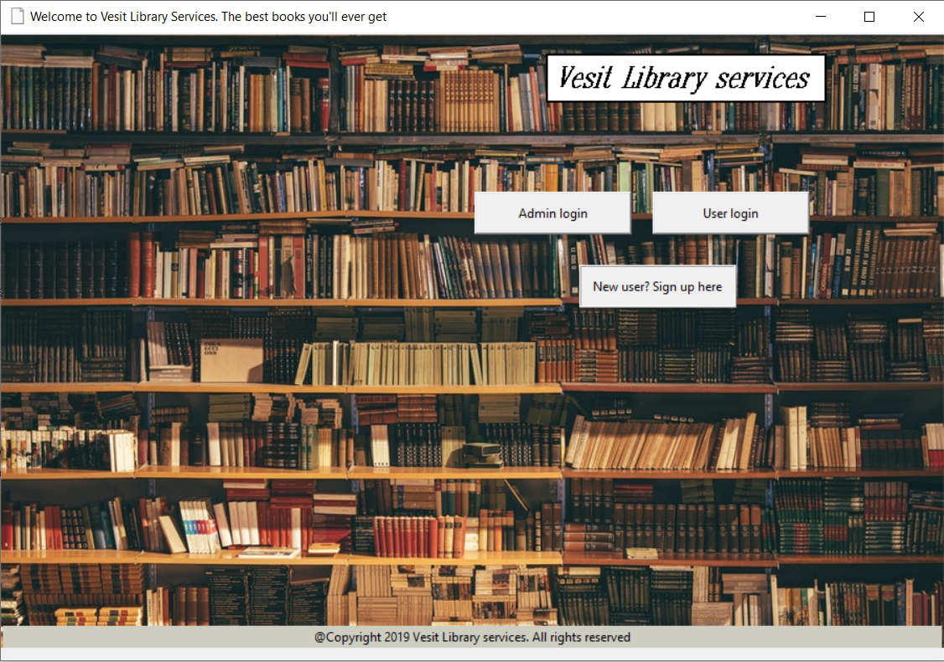

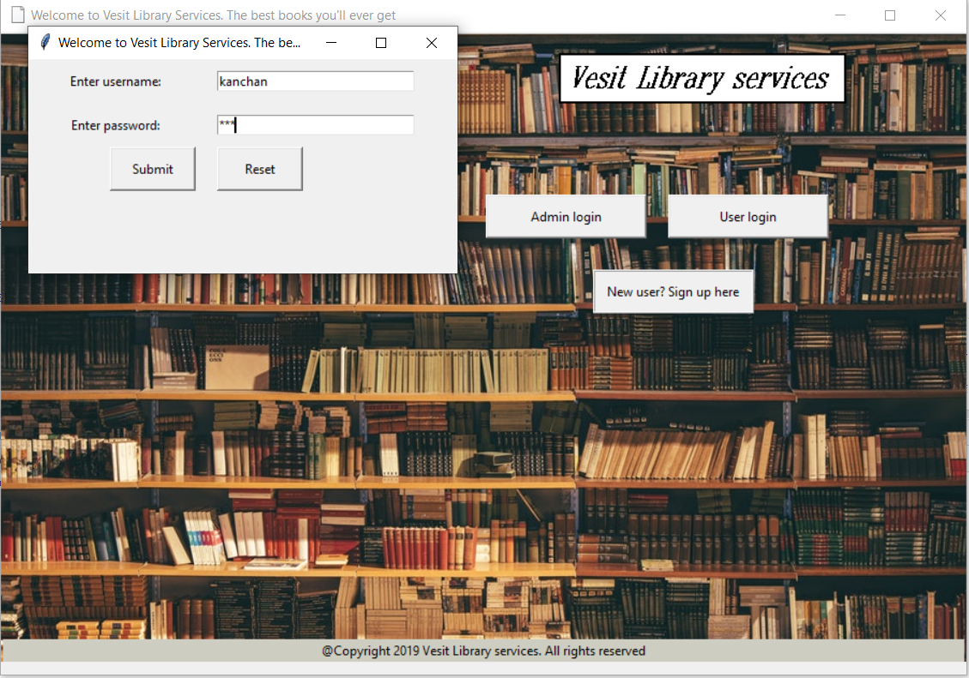

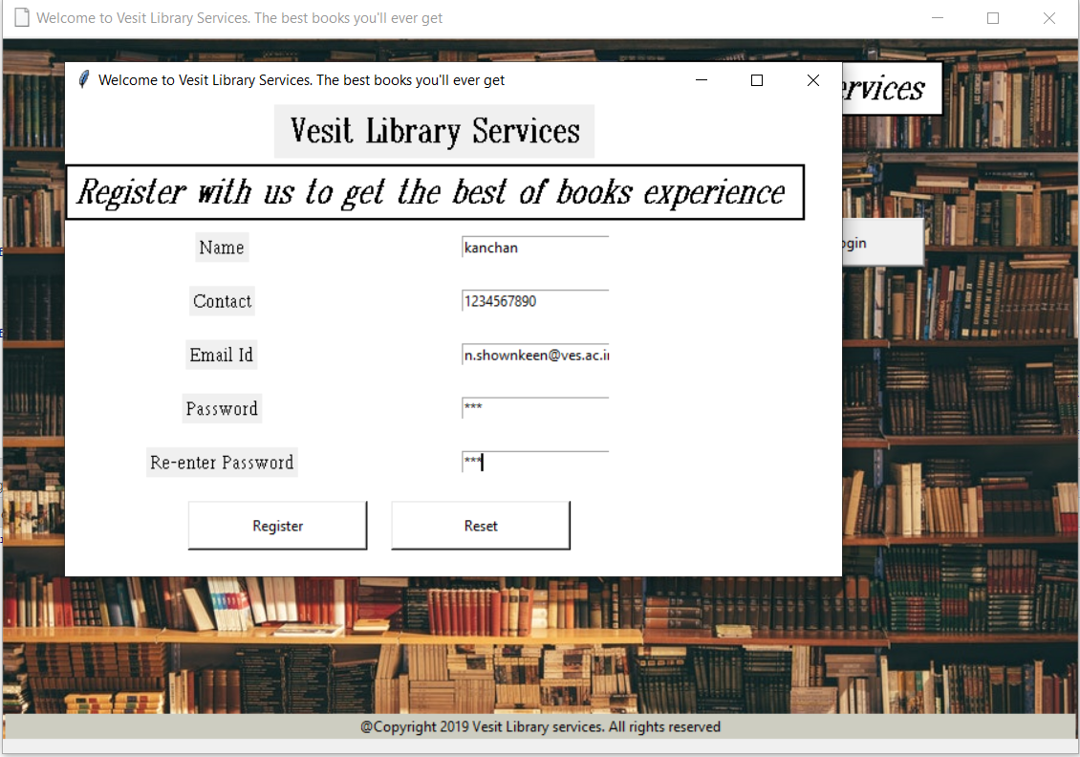

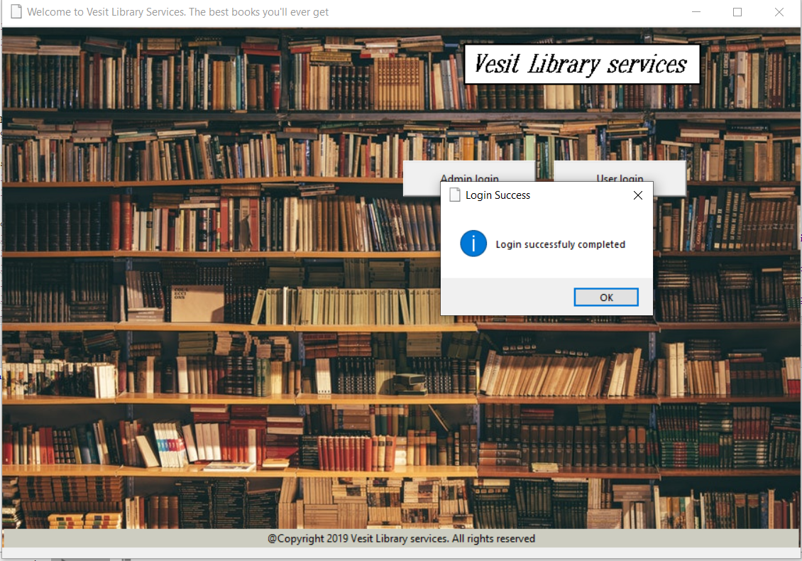

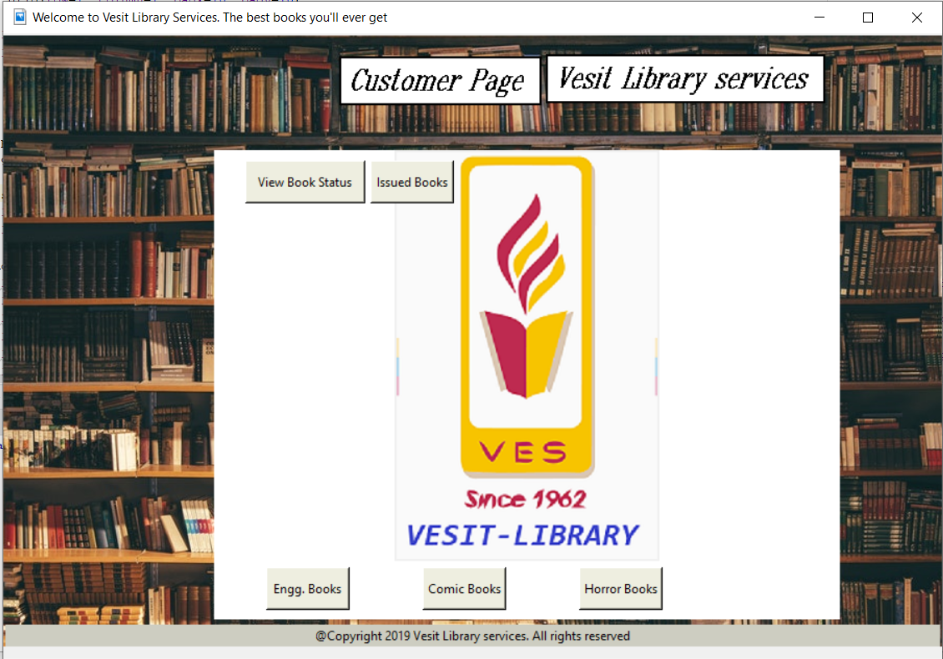

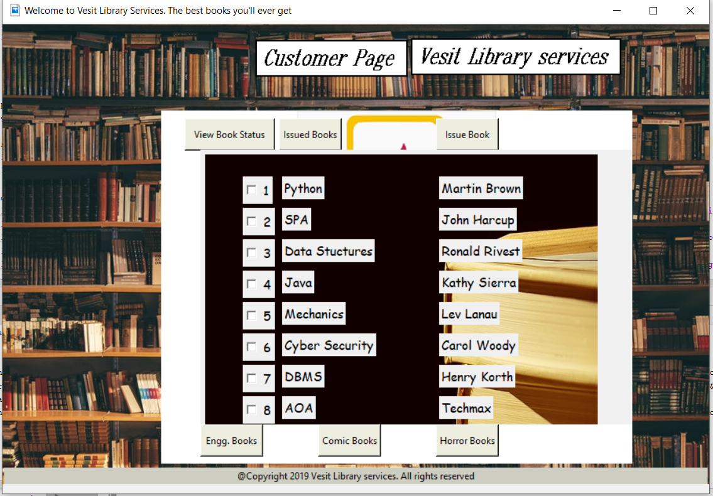



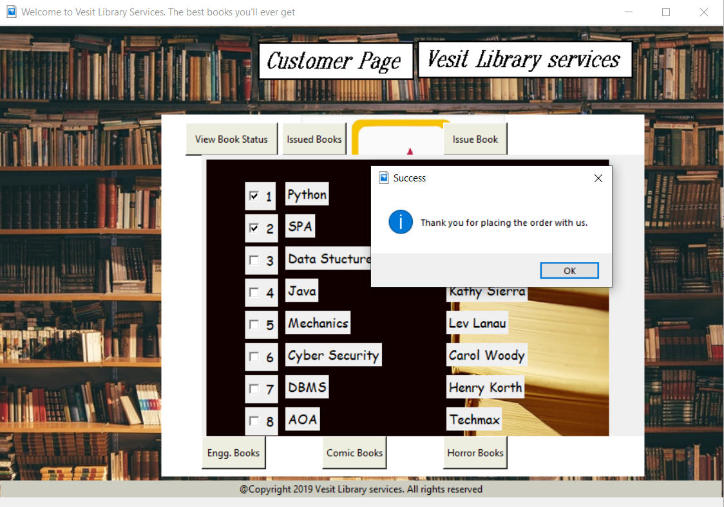

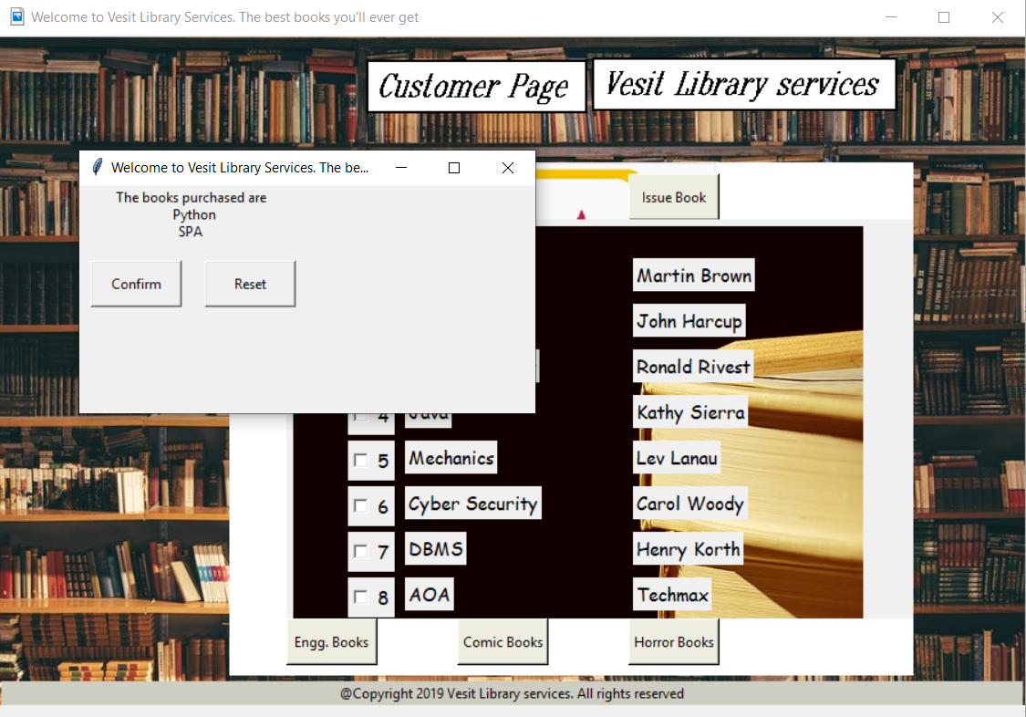

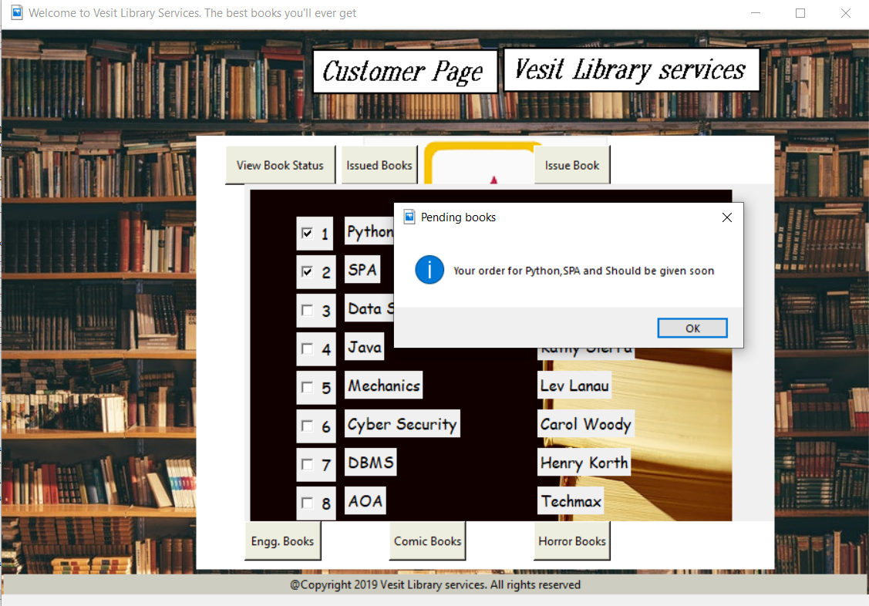

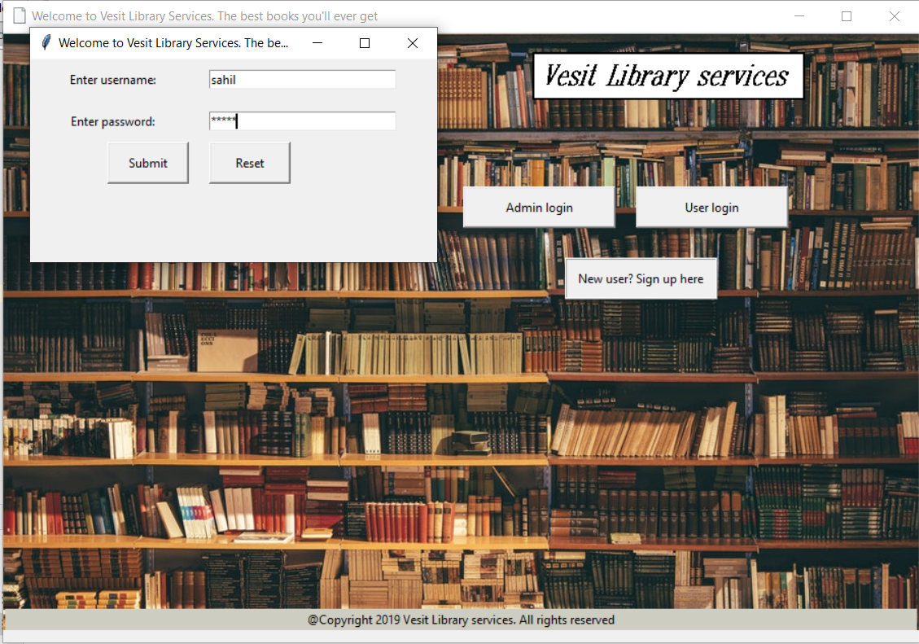

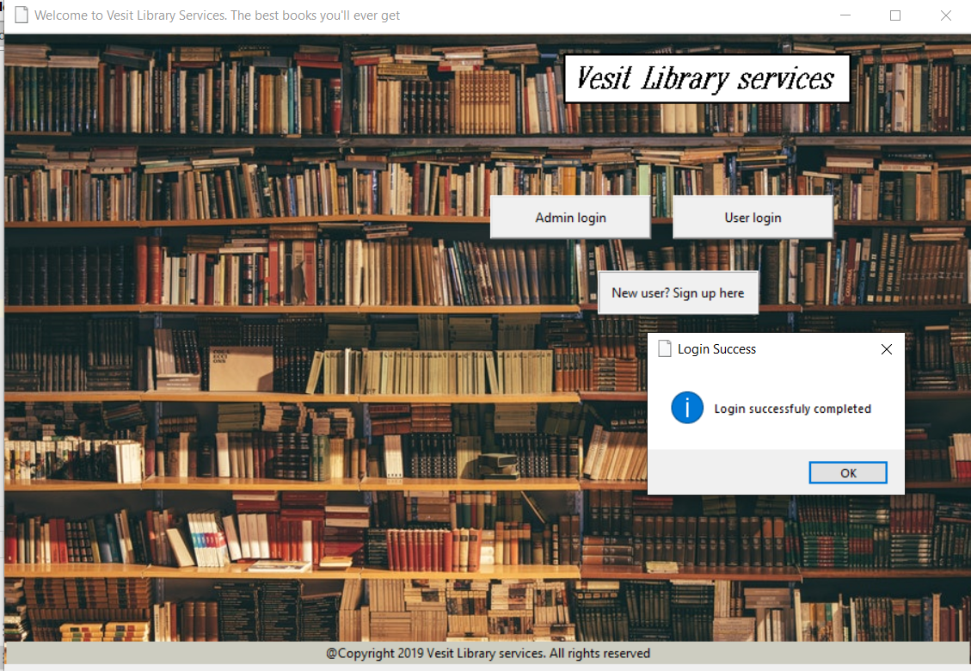

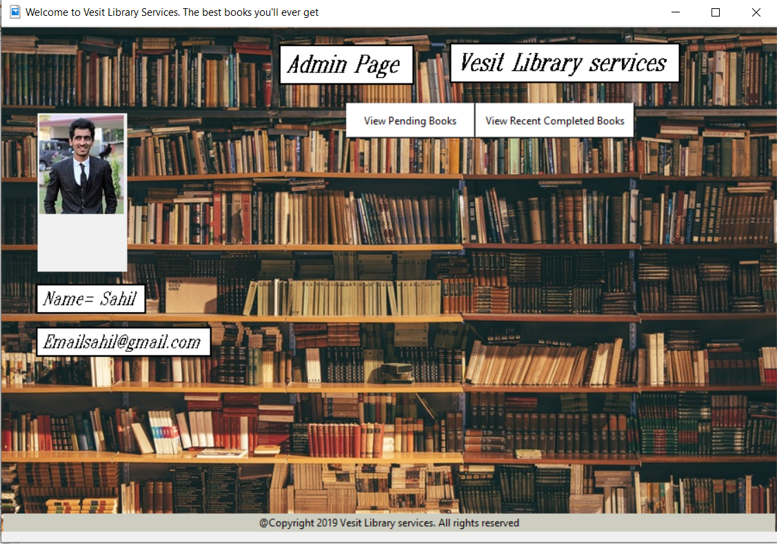

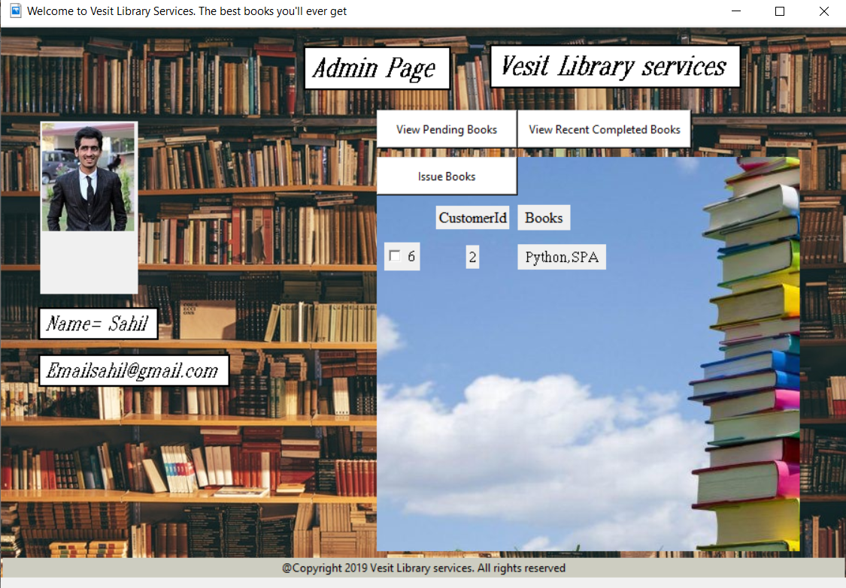

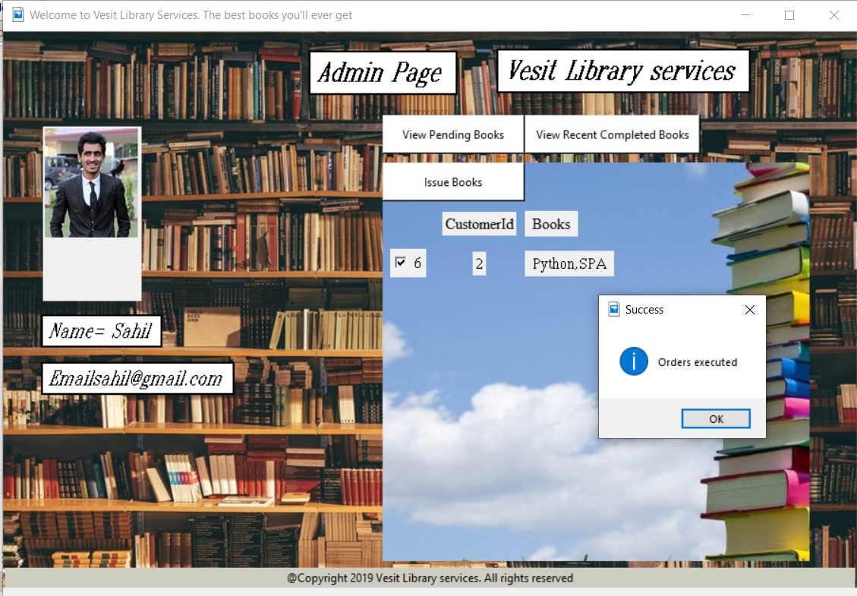

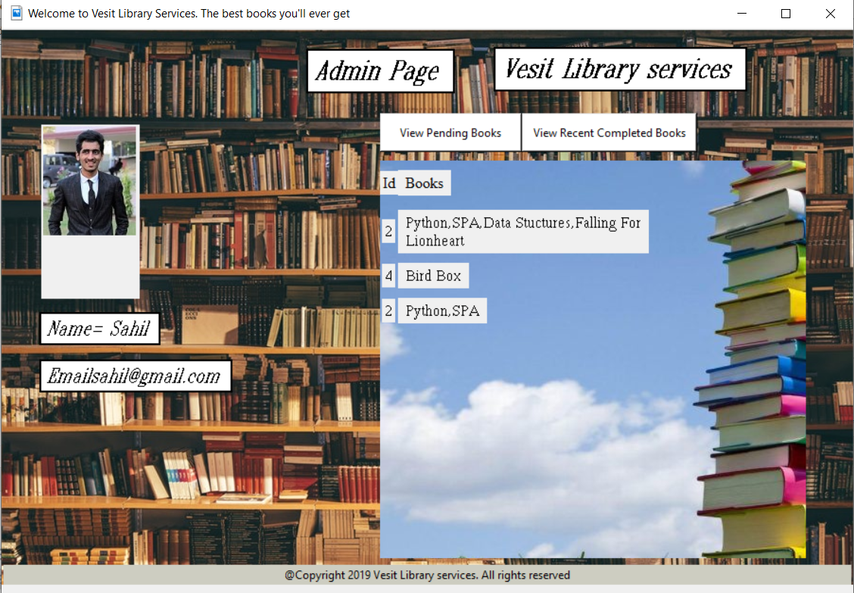

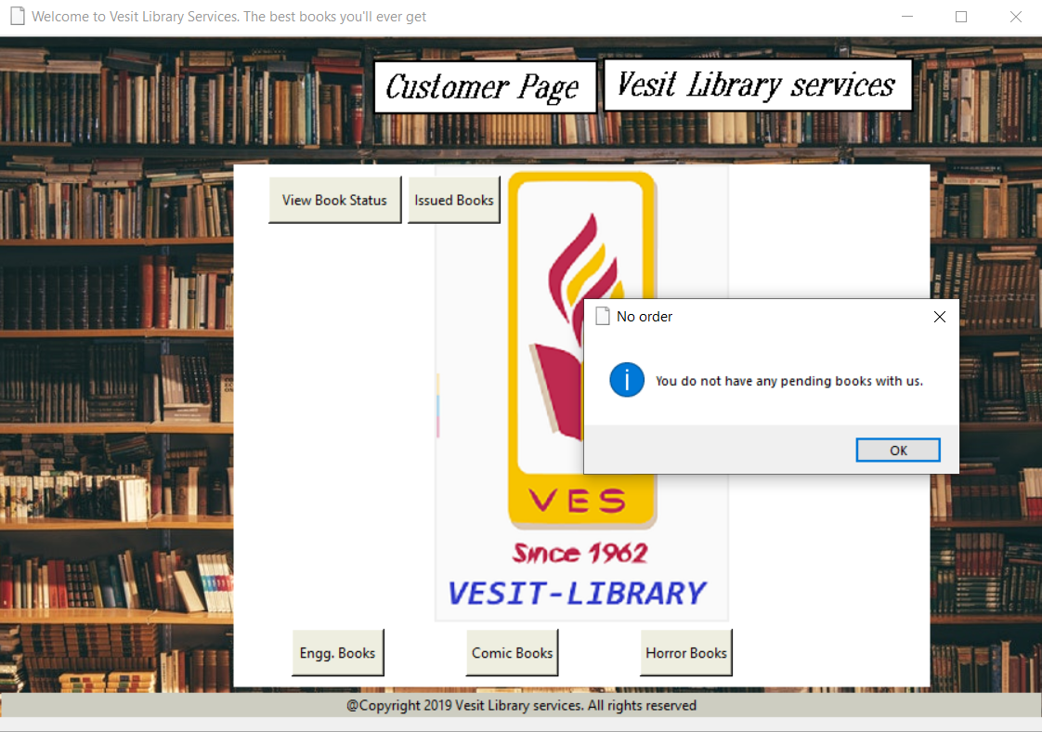

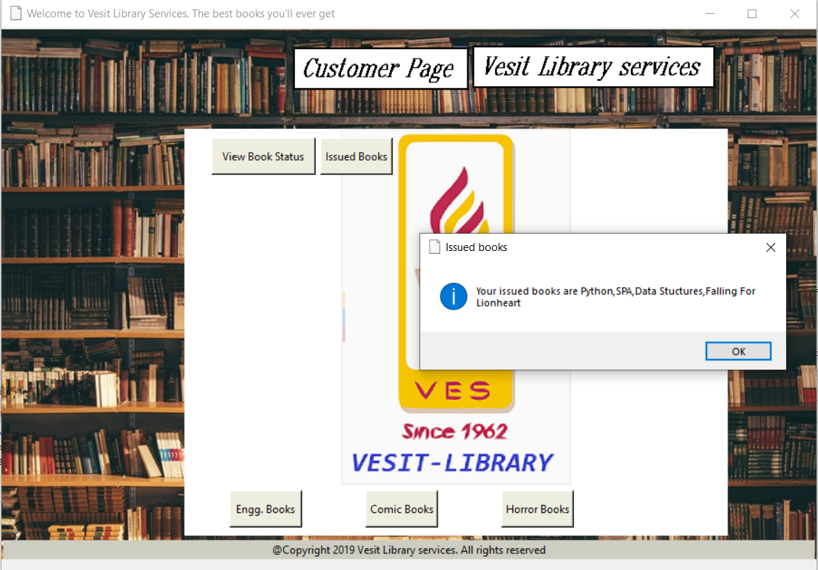

**Conclusion:**

Thus, the data is stored in the database of library management system using MySql.the basics of python language were implemented successfully.

**References:**

<https://en.wikipedia.org/wiki/Library_management>

<https://docs.python.org/2/library/commands.html>